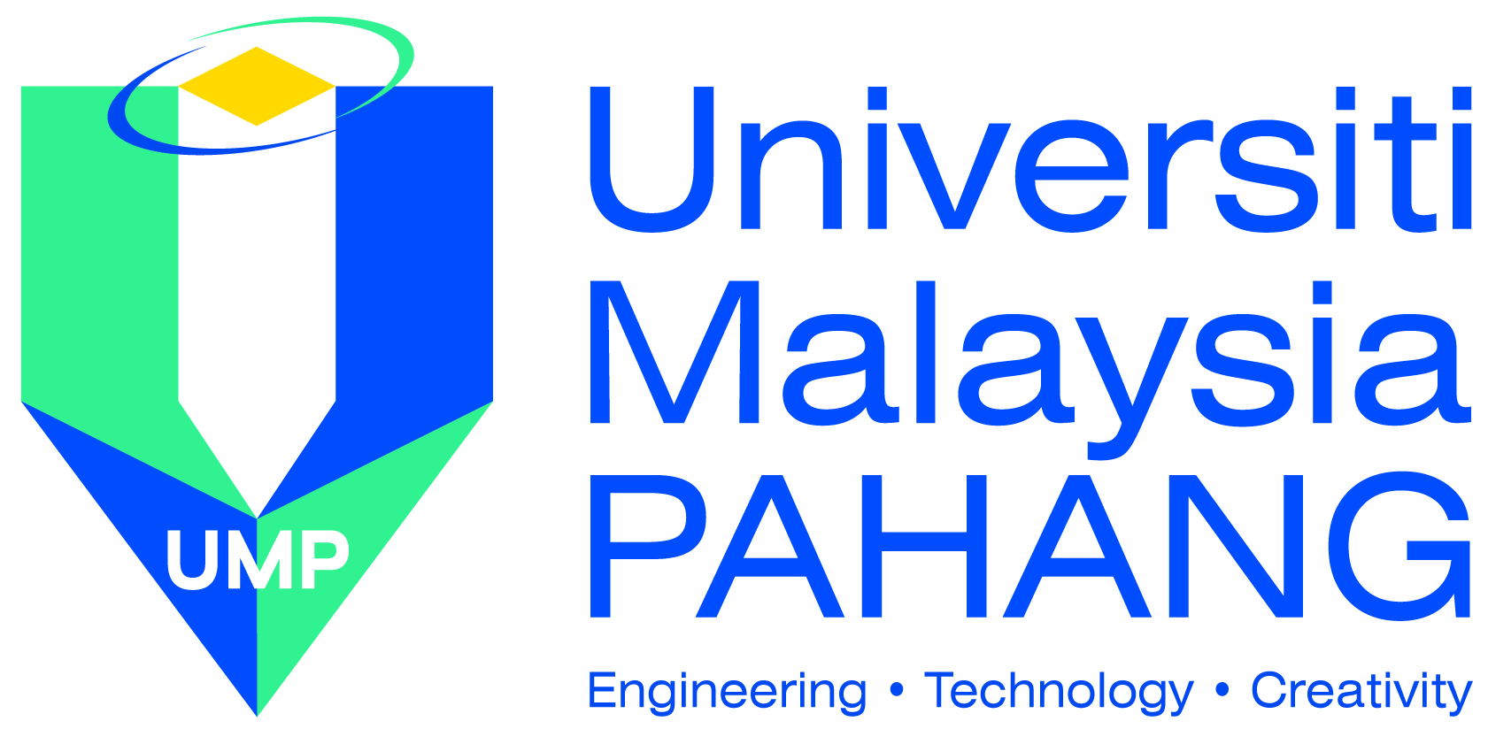

Faculty of Industrial Management

Course : LEAN MANAGEMENT
Course Code : BPT2633
Credit Hour : 3 hours
Rationale : Elective
Contact Hours : Lecture 3 units (3hrs x 14 weeks)
Pre-requisite : None
Lecturer : Ahmad Nazif Bin Noor Kamar
Office : A2-02-05
Telephone : 09-5492268
Fax : 09-5492167
E-mail : nazif@ump.edu.my

Synopsis

This course introduces the key concepts in lean manufacturing such as continuous improvement, just-in-time, standardization, kanban, single minute exchange of dies (SMED) and others. Lean focuses on eliminating waste in processes, waste being anything that impedes the flow of product as it is being transformed in the value chain. The course will examine the socio-technical interactions within a modern manufacturing organization and develop skills and processes for implementing changes for achieving agile manufacturing and global competitiveness.

Objective

At the end of the course, students should be able to:

- Analyze various concepts of lean systems and their applications in the manufacturing and service industry.

- Develop the skills by applying lean tools and techniques in solving organization or industry problems.

- Adapt lean principles in initiating a continuous improvement program in an organization.

Assessment

- Test (2X) 30%
- Assignment (2X) 30%
- Final Exam 40%
TOTAL 100%

Course Structure : Sem I Session 2014/2015

Week | Date | Topics
1 | 9 & 11 Sept. 2014 | Overview of Lean Management
2 | 18 Sept. 2014 | Lean Thinking
3 | 23 & 25 Sept. 2014 | Lean Thinking
4 | 30 Sept. & 2 Oct. 2014 | Lean Foundations
5 | 7 & 9 Oct. 2014 | Takt Time & Work Standardization
6 | 14 & 16 Oct. 2014 | Takt Time & Work Standardization
7 | 21 & 23 Oct. 2014 | Mid Term Break
8 | 28 & 30 Oct. 2014 | Improvement Cycles
9 | 4 & 6 Nov. 2014 | Lean Material Systems & Kanban
10 | 11 & 13 Nov. 2014 | Lean Material Systems & Kanban
11 | 18 & 20 Nov. 2014 | Kaizen Events
12 | 25 & 27 Nov. 2014 | Quality, Mistake Proofing & Line Layout
13 | 2 & 4 Dec. 2014 | Quality, Mistake Proofing & Line Layout
14 | 9 & 11 Dec. 2014 | Lean Tools - SMED & VSM
15 | 16 & 18 Dec. 2014 | Revision
16 |  | STUDY WEEK
17 |  | Final Exam

References

Koenigsaecker, G. (2013) 'Leading the Lean Enterprise Transformation', CRC Press 2nd Ed

Fliedner, G. (2012) 'Leading and Managing the Lean Management Process', Business Expert Press 1st Ed., New York

Nicholas, J. (2011) 'Lean Production for Competitive Advantage: A Comprehensive Guide to Lean Methodologies and Management Practices', Productivity Press, New York

Floyd, R. C. (2010) 'Liquid Lean: Developing Lean Culture in the Process Industries', Productivity Press, New York

